You can get a sample project from the below website on your browser.

[www.initializr.com](http://www.initializr.com)

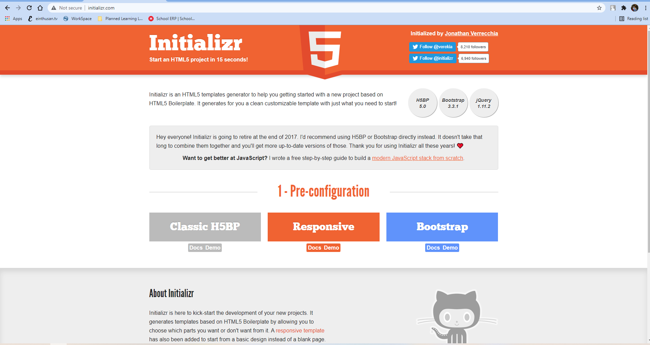

Here I want download Bootstrap project, so I click on Bootstrap option.

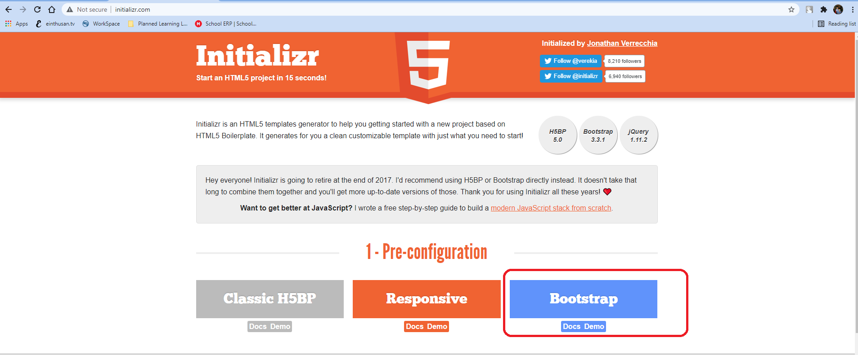

Select the required file and click on Download it.

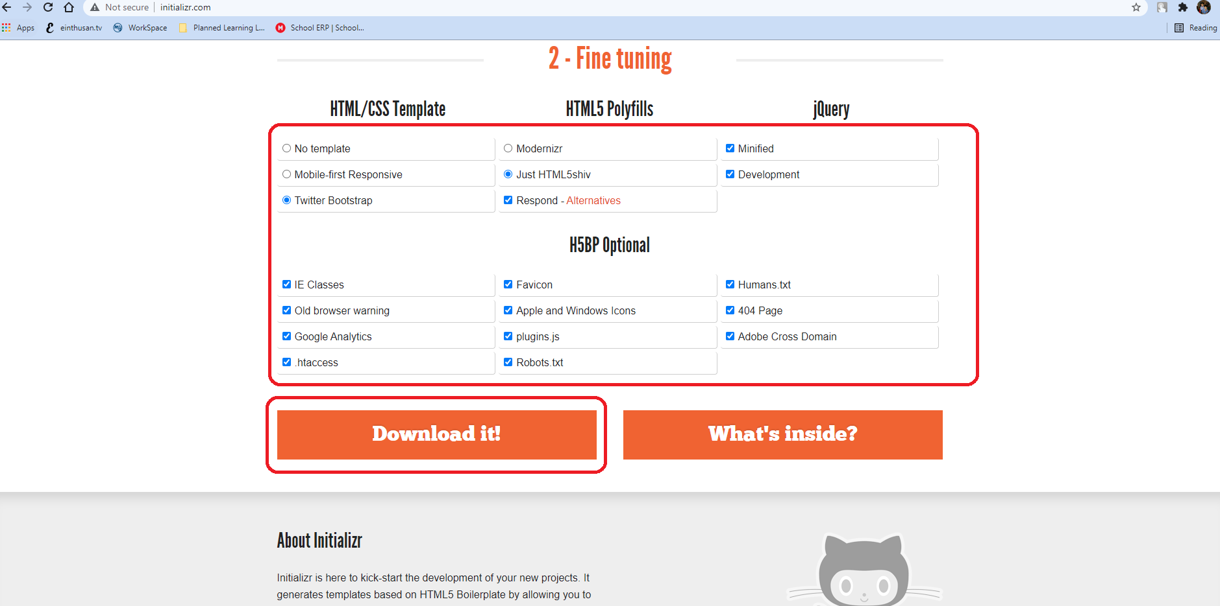

The file had been downloaded and placed on the respective directory.

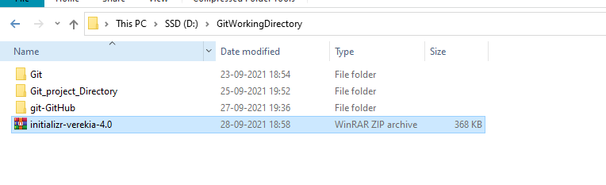

Now unzip all the files and rename the respected directory.

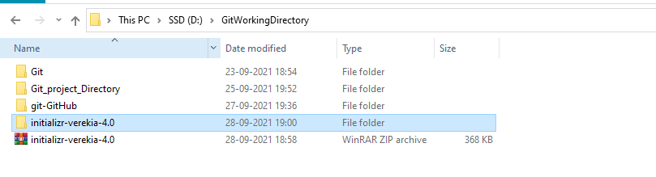

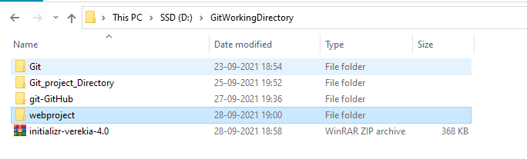

Now I am making this webproject as my git repository. For this I need to enter into the respected directory and issue the command mentioned below.

# git init

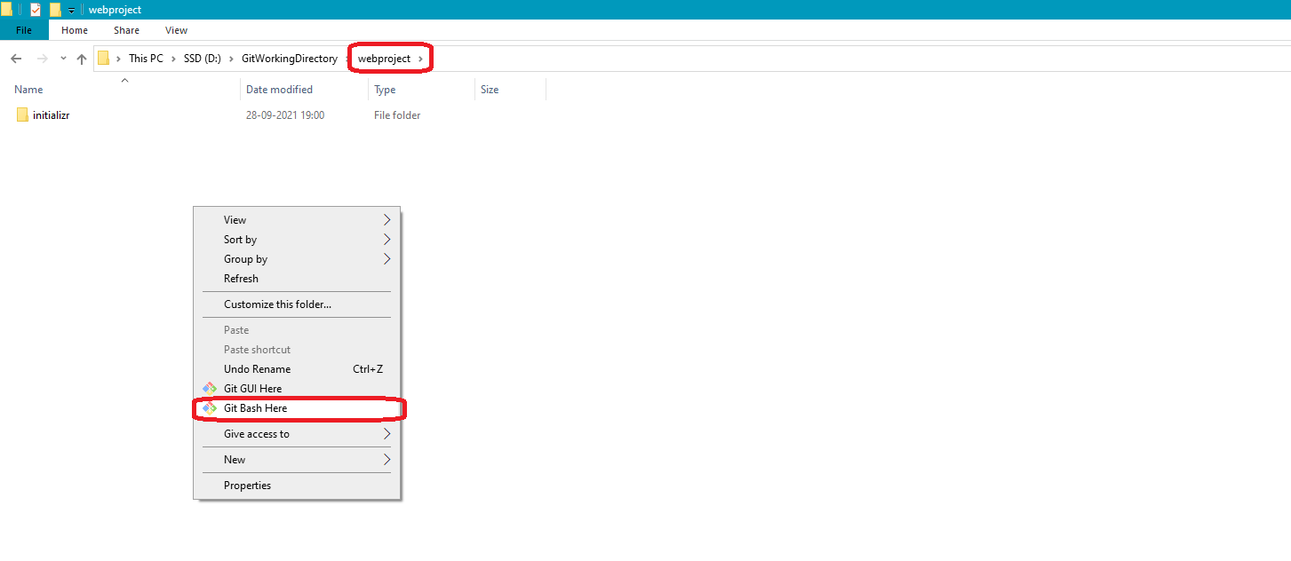

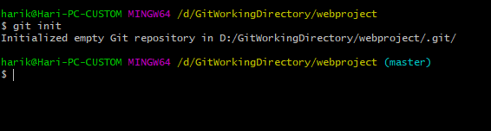

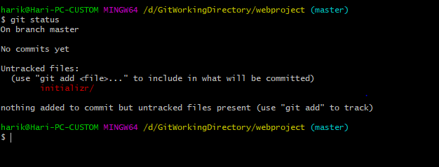

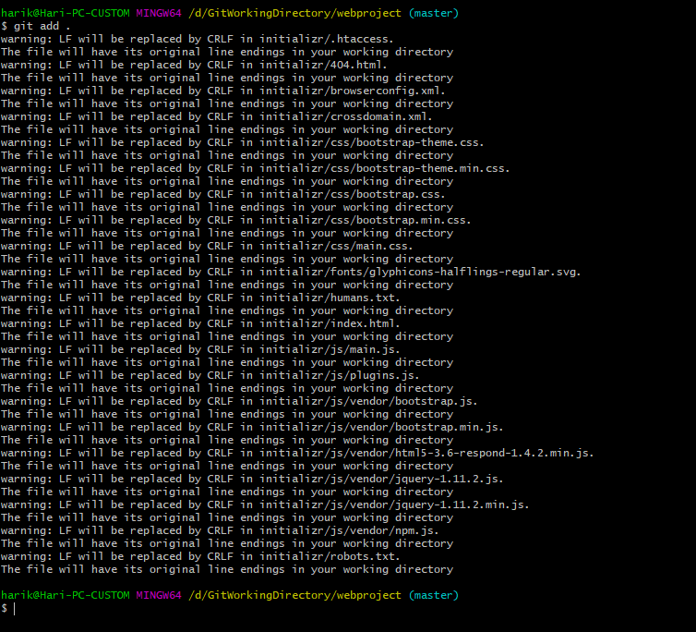

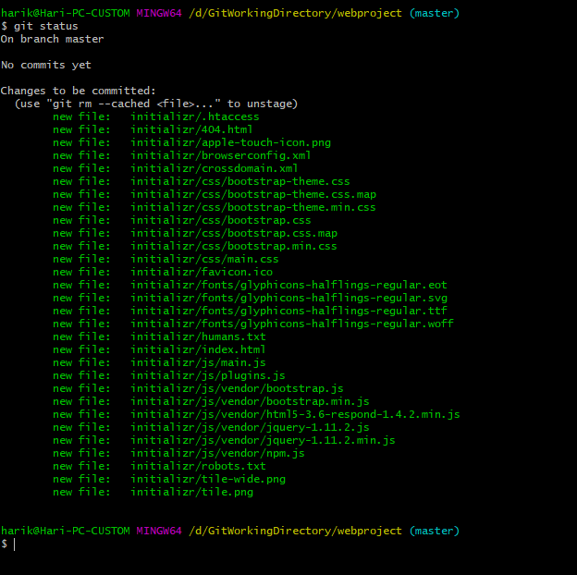

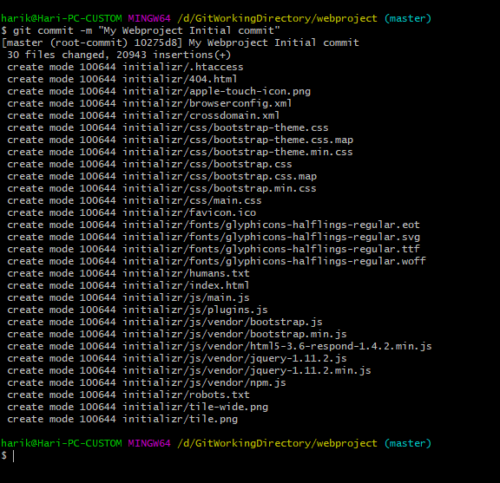

Now I want to push this code the centralized repository by creating the respected repository there.

I logged into the github.com using my credentials. In order to login or create credentials please refer to the old documentation.

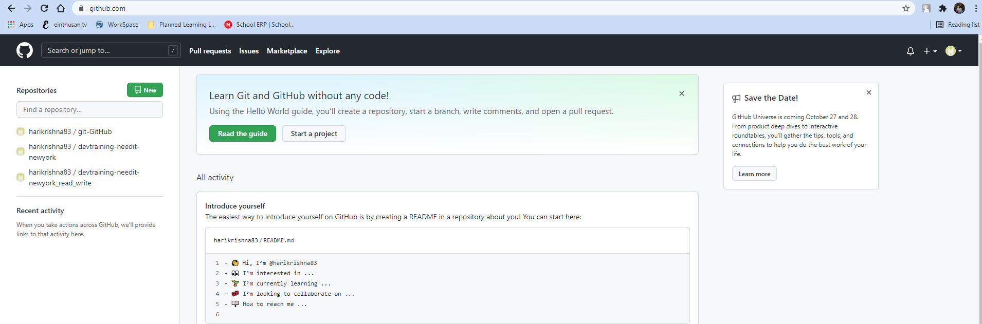

Click on + sign at top right hand corner and click on “New repository”.

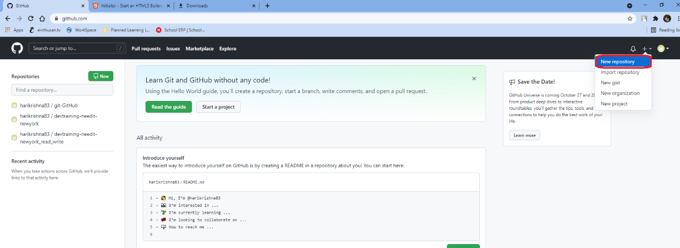

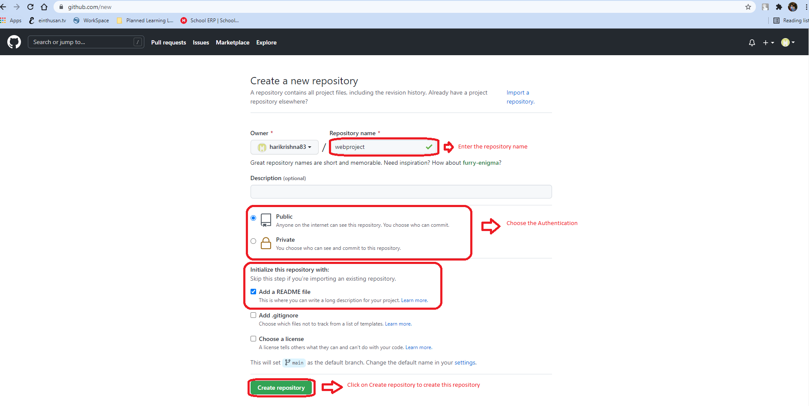

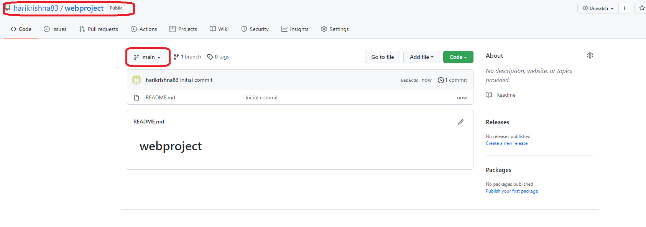

By default on github the repository comes with the branch main, but on my local repository default branch is master and my webproject exists on master branch only. So I will create a branch master on github.

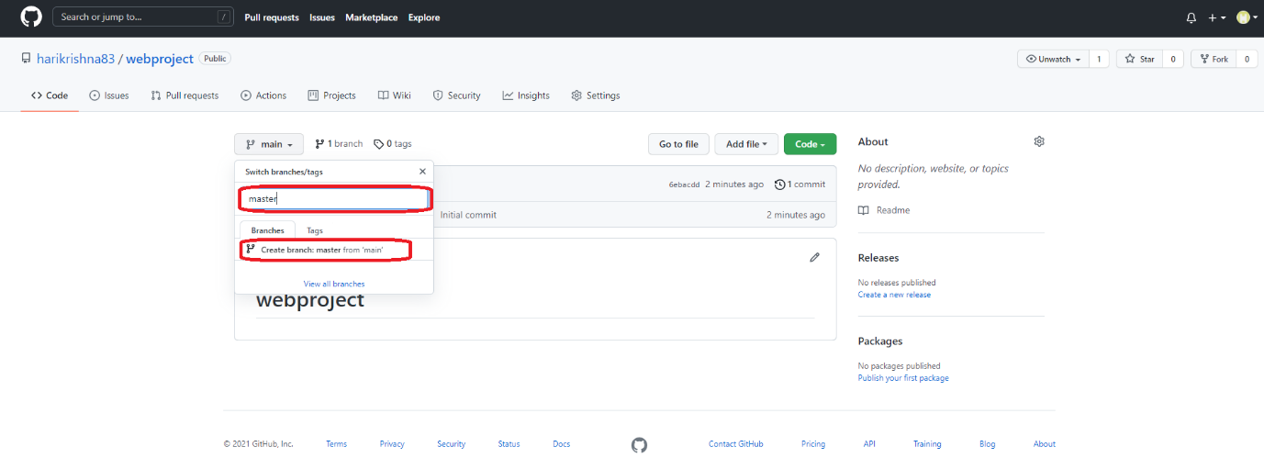

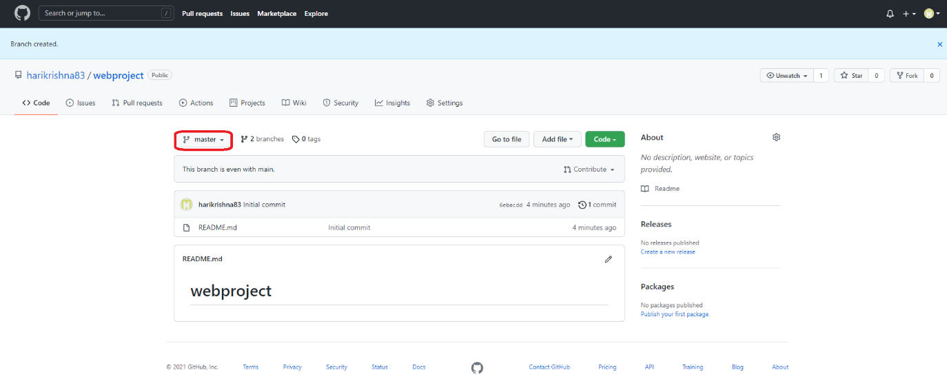

Click on code and copy the https url

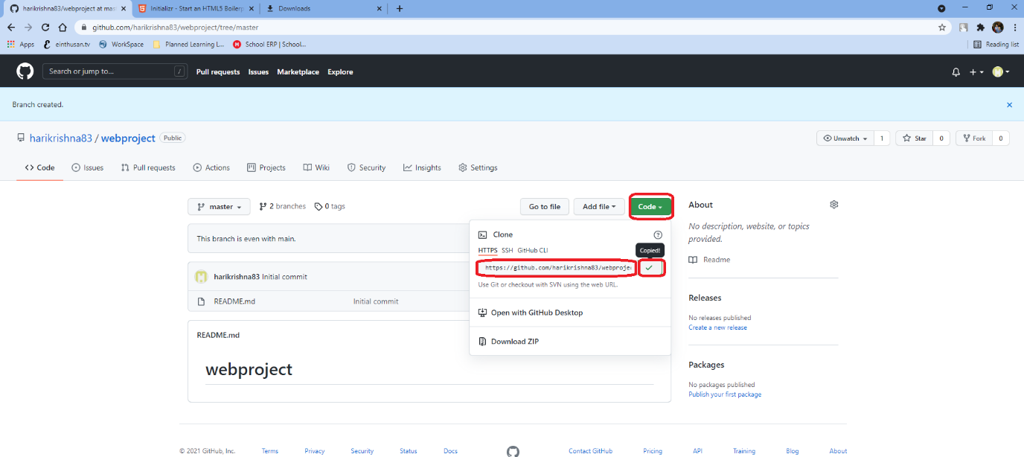

Now login to the local repository and issue the below command to first originate a link from your local repository to your centralized repository.

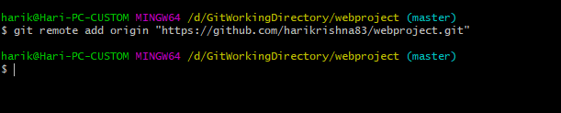

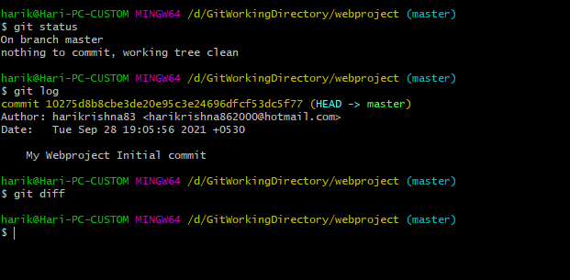

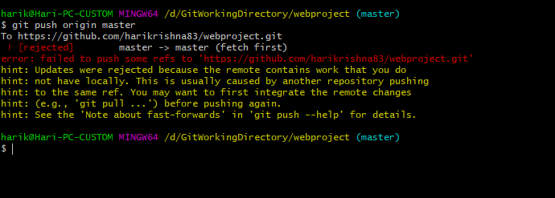

Here the above command was failed because there are already some updates exists on remote master repository, and it is asking to pull those by using the command git pull.

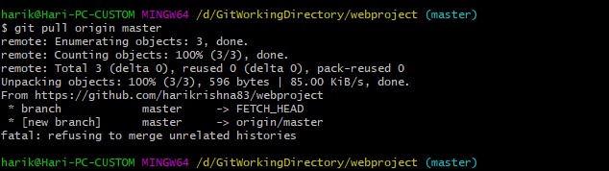

Here also it thrown an error saying refusing to merge unrelated histories, this error is resolved by toggling the *allow-unrelated-histories* switch.

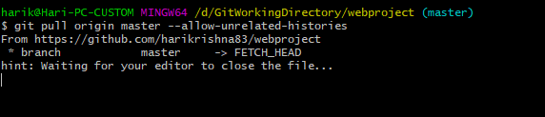

It will open a file with the editor that are configured on your git. Close that file and total notepad ++ application.

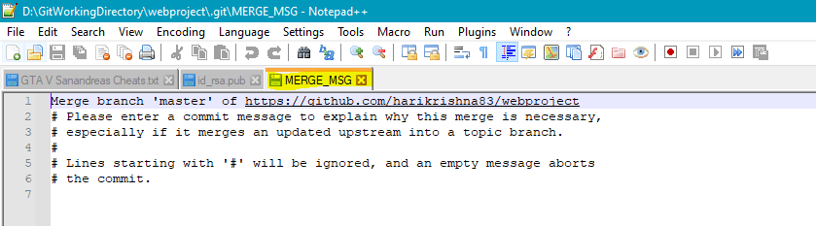

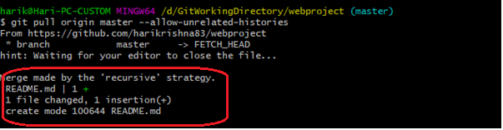

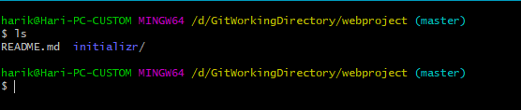

Now push the local repository code to centralized repository.

